Media Release

Phonak Roger On remote microphone honored at 2024 Edison Awards Gala

Award coincides with 100,000 Roger On devices in use worldwide
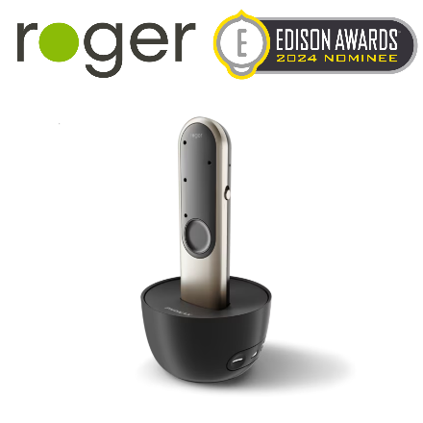
Stäfa, Switzerland, April 23, 2024 – Phonak, a leading global provider of life-changing hearing solutions, announces that its Roger On remote microphone has been recognized as a 2024 Edison Awards Bronze Winner for innovation in the Personal Technology & Gadgets/Assistive Technologies category. The prestigious award marks the sixth major product recognition for Roger On and coincides with 100,000 Roger On devices in use worldwide.

"Receiving an Edison Award in the Assistive Technologies category not only underscores the ingenuity behind our product, but also its profound impact on enhancing lives through accessible hearing technology,” said Laurent Saada, Managing Director, Sonova Communications AG. “Roger On is like a third ear for hearing aid wearers and cochlear implant recipients. It empowers people to fully engage in conversations, breaking barriers and fostering deeper connections with one another. In fact, this achievement comes at a time when we celebrate 100,000 human connections made possible each day thanks to Roger On.”

Unveiled in 2021, the Phonak Roger On helps hearing aid wearers and cochlear implant recipients hear and understand speech in noisy situations and over distance. It automatically detects whether it’s being used on a loud dinner table, in hand-held pointing mode, or worn as a neck loop or lapel mic during a presentation. The capabilities of Roger On extend beyond simply transmitting speech directly into one’s ears. It instantly detects the direction of speech and automatically adjusts its settings to provide the best listening experience.

In 2023, in response to the increasing number of people utilizing video conferencing at home, headset functionality was added to support two-way audio streaming when connected to a computer via USB. Since its debut, Roger On has been the recipient of numerous product design and accessibility honors including Red Dot and iF Design awards, German Innovation and Hearing Technology Innovator awards, and was also named a TIME 2021 Best Inventions Special Mention.

"The judges were thrilled to honor Phonak’s Roger On as a groundbreaking category-changer this year, showcasing the power of innovation to improve our lives for the better," added Frank Bonafilia, executive director of the Edison Awards.

The 2024 winners were evaluated through a thorough judging process based on four essential criteria: Concept, Value, Delivery, and Impact. A panel of leading business executives, past award winners, and esteemed professionals carefully assessed each product.

For more information on Roger On, please visit the Phonak website.

Media relations contacts:
Global
Florence Camenzind
Phone +41 58 928 33 25
Email florence.camenzind@sonova.com

U.S.
John Urbaniak
Phone +1 331 204 2799
Email john.urbaniak@sonova.com

– End –

About Phonak
life is on. Since 1947, Phonak has been dedicated to improving the quality of life for people with hearing loss. Seventy-five years later, our passion for creating life-changing hearing solutions that help people thrive physically, socially, and emotionally remains. By offering the industry’s broadest portfolio of hearing solutions, we are committed to creating a world where “life is on” for everyone. At Phonak, innovation is not limited to products. We work to change the conversations surrounding people with hearing loss. We do this by fighting the stigma of hearing aids and creating an understanding of how hearing is connected to the broader context of healthy living.

About the Edison Awards™
Established in 1987, the Edison Awards are dedicated to recognizing, honoring and fostering innovations and innovators. Named after Thomas Alva Edison (1847-1931), the annual competition honors excellence in new product and service development, marketing, design and innovation. For more information visit www.edisonawards.com.

