Media Release
Phonak unveils Virto Black at CES: a fully-connected hearing aid shaped like a hearable

Stigma-busting Virto Black combines exceptional sound quality, universal Bluetooth® streaming, and up to 10x better-than-normal hearing with Roger® technology

Stäfa, Switzerland / Las Vegas, USA, January 6, 2020 – Leading hearing health care brand Phonak is challenging perceptions of hearing aids at CES 2020 with the world premiere of Phonak Virto Black, a fully-connected in-the-ear (ITE) hearing aid that combines breakthrough Marvel hearing technology with the style of a modern hearable.
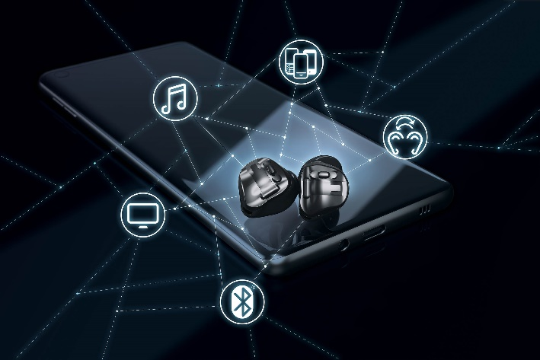
Virto Black is Phonak’s first custom-made hearing aid with the benefits of Marvel technology, including universal Bluetooth streaming, hands-free phone calls, and a personalized hearing experience via the myPhonak app. When paired with a Roger accessory, Virto Black wearers can also experience up to 10x better-than-normal hearing in noisy situations and over distance by streaming the Roger signal directly into both ears.¹

A world of connectivity
Virto Black is the world’s first custom-made hearing aid that directly streams from both iOS®, Android™, or virtually any other Bluetooth®-enabled audio device. It boasts up to 16 hearing performance features that work together to help wearers connect with everyone in their life. Meanwhile its microprocessor chip runs five wireless protocols at the same time including Bluetooth Classic, Bluetooth LE, Binaural VoiceStream Technology™, Airstream Technology™ and Roger, providing the wireless connectivity that today’s wearers expect.

With Virto Black, hearing aid wearers can answer, end, or reject a phone call with a simple push of a button while keeping their phone in their pocket, purse, or on a nearby table. On-board microphones allow wearers to use their devices as wireless headsets, resulting in truly hands-free conversations.

Customized on the outside, personalized on the inside
All Virto Black hearing aids are custom-made using state-of-the-art 3D printing technology and then expertly assembled by hand. On the inside, Virto Black delivers a personalized hearing experience thanks to Biometric Calibration, which analyzes 1,600 unique data points from a person’s ear impressions to optimize directional microphone placement and ensure an exact fit.

Unlike traditional hearables, Virto Black’s custom fit means the devices can be comfortably worn all day and won’t fall out during exercise. Its advanced hearing technology facilitates better communication with friends and loved ones instead of limiting the wearer to a typically one-way consumption of streamed content that’s common with some hearables.

Confronting the hearing aid stigma
Nearly 40 million Americans and 5 percent of the world’s population has hearing loss and the average person waits seven years to seek treatment². Despite tremendous technological advances and a growing body of research linking untreated hearing loss to more severe health conditions, hearing aids are still widely viewed as undesirable.

Virto Black was designed to blur the lines between a hearing aid and a hearable and help people seek treatment sooner thanks to the stylish design and innovative hearing aid technology designed to meet the needs of even severe hearing losses. A recent survey of more than 600 persons with hearing loss showed that the majority of non-wearers would choose Virto Black in comparison to traditional hearing aids³. This was most prominent in the 18-56 age range, suggesting younger wearers may be more comfortable wearing a bold, stylish product like Virto Black in their ears.

Virto Black will be available to the public beginning February 19 in the U.S. through licensed hearing care professionals.

1. Thibodeau, L. (2014). Comparison of speech recognition with adaptive digital and FM wireless technology by listeners who use hearing aids. American Journal of Audiology, 23(2), 201-210
2. Deafness and hearing loss: World Health Organization; 2019. Retrieved from https://www.who.int/news-room/fact-sheets/detail/deafness-and-hearing-loss
3. Stöcklin, R. (2018) Market Research ID1345. Please contact marketinsight@phonak.com if you are interested in further information.

Bluetooth® word mark is a registered trademark owned by Bluetooth SIG, Inc. and any use of such mark by Sonova AG is under license.
IOS is a trademark of Cisco Technology, Inc.
Android is a trademark of Google LLC.

Note
*CES media attendees who would like a hands-on demonstration to learn more about Virto Black can visit Phonak Sound Experience Club, January 6-9 at The Venetian, Suite 30-326. Appointments are recommended but not required. Phonak will also demonstrate Virto Black on January 6 at Pepcom’s Digital Experience! from 7:00-10:00 p.m. at The Mirage and on January 7 at ShowStoppers! from 6:00 – 10:00 p.m. at The Wynn. For general information, please visit www.virtoblack.com.

Media Relations Contacts:

Global
Florence Camenzind
Phone +41 58 928 33 25
Email florence.camenzind@sonova.com

U.S.
John Urbaniak
Phone +1 331 204 2799
Email john.urbaniak@sonova.com

Asia/Pacific
Heidi Zhang
Phone +86 13001271545
Email heidi.zhang@sonova.com

– End –
About Phonak
Headquartered near Zurich, Switzerland, Phonak, a member of the Sonova Group, was created in 1947 out of a passion for taking on the most difficult hearing challenges. Seventy years later, this passion remains. As the industry’s leading innovator, we offer the broadest portfolio of life-changing hearing solutions. From pediatric to profound hearing loss, we remain committed to creating hearing solutions that change people’s lives to thrive socially and emotionally. We believe in creating a world where ‘Life is on’ for everyone.
At Phonak, we believe that hearing well is essential to living life to the fullest. For more than 70 years, we have remained true to our mission by developing pioneering hearing solutions that change people’s lives to thrive socially and emotionally. Life is on.

